**User Manual**

For

Cateina CMS Portal

|  |  |
| --- | --- |
| Version No: | 1.0.0 |
| Release Date: | 17th July 2019 |

Prepared By – Rushikesh Mokashi, Suchit Gupta



All rights reserved. The copyright in this work vests with Cateina Technologies Pvt Ltd (hereinafter referred as Cateina). No part of this work, can be reproduced,

stored in whole or in part, or transmitted in any form or by any means of electronic, mechanical, photocopying or otherwise, or used or disclosed without the prior

express written consent of Cateina.

Table of Contents

1.Introduction

2.Selecting/Deselcting Elements

3.Path Calculation

4.Root path Calculation

5.Start

# 1.Introduction

**What is Cateina?**

At Cateina, we build products and solutions that enable reconstruction of legacy business practices and drive growth. Our passion reflects in our work and Customer satisfaction. Our innovation is the first priority, doing what has not been done before is what we aim for, here at Cateina Technologies.

Enterprise Application Integration (EAI)

Cateina's Enterprise Application Integration (EAI) Practice provides the tools enterprises need for connecting cloud and on-premises applications, building microservices and exposing and managing APIs. It enables you to reach new markets, rapidly take advantage of new business opportunities and improve communications within your partner ecosystem

Blockchain Technology (BCT)

Blockchain offers a radical new computing paradigm of decentralized networks challenging conventional processes across industries and society. Cateina’s Blockchain Technology (BCT) Practice and expertise will enable you to explore and navigate the potential of Blockchain and pilot solutions customized to your business needs

**What is the Cateina API graph generator?**

The Cateina API graph generator will generate a tree diagram with each node as a separate data entity connected to other data entities connected to each other via links.

The nodes display attributes namely the name, the type of node as an image and are connected to each other via links according to their tree-based hierarchy.

The links display the type of connection between two nodes.

Various functionalities have also been added to the graph which are elaborated on below.

# 2.Selecting/Deselecting Elements

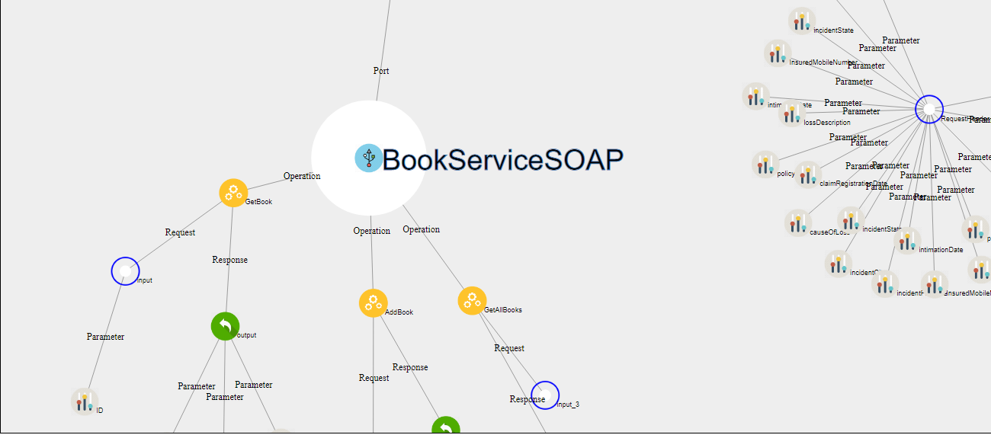

* To select any node, one has to **left-click** on that node.
* At any given time only two nodes can be selected.
* Existing nodes can be deselected by **right-clicking** on them.
* Upon selecting the nodes various functionalities such as path and neighbour display can be used.

# 3.Path Calculation

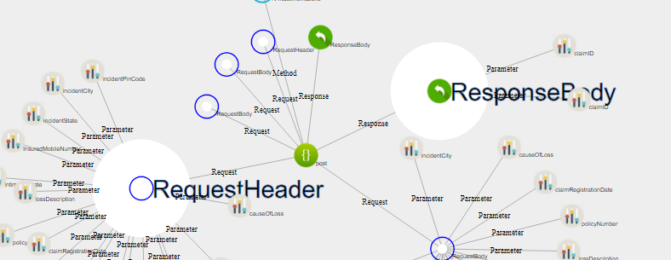

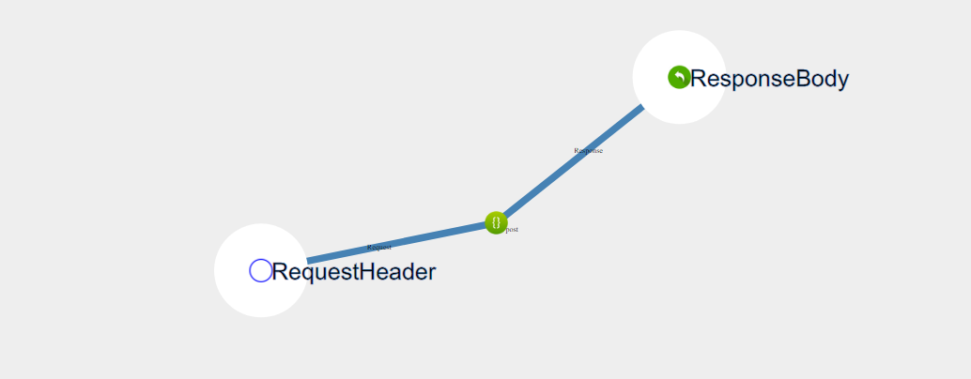

* After selecting two nodes and clicking on **Path** button, the path between two nodes will be highlighted.
* Path button wont work unless two nodes are selected.
* Instead of selecting the nodes on screen, the user can also enter the two nodes via the dropdown options and then click on the path button.
* There cannot be any path between two different trees. If nodes between two different trees are selected then an error message will be returned at the bottom of the screen saying no path between two trees.
* Also care must be taken that the input boxes be cleared before trying to find out any other path.





# 4.Root Path Calculation

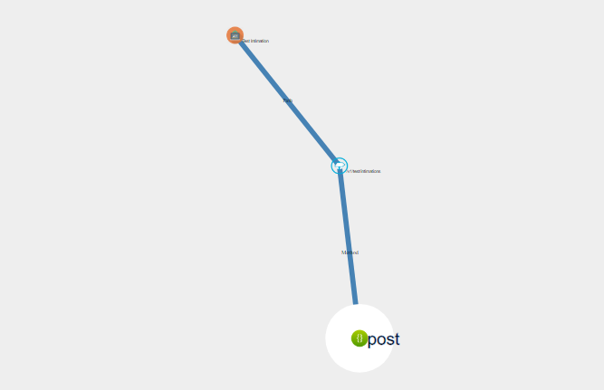

* For determining the root path, select a single node only through on-screen left-click selection.
* After selection click on the **root path** button to display the path from the selected node to its respective tree root.



* The root path functionality wont work with the dropdown selection option. If locating the current node is an issue, use the **Search** functionality to identify the node required

# 5.Start

Before start :-

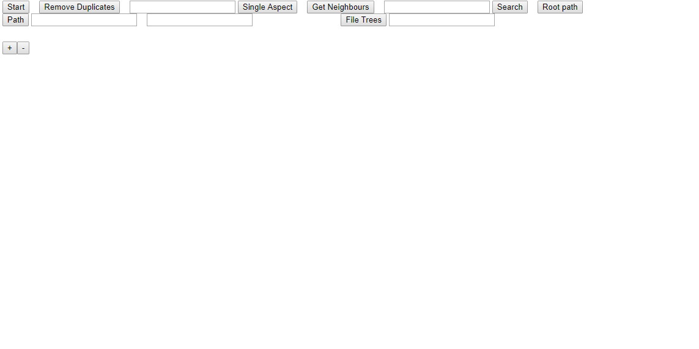

After start:-

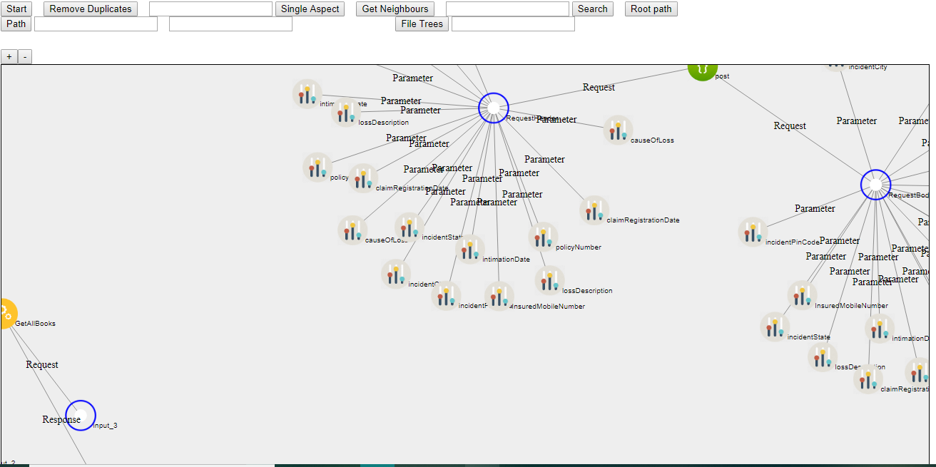

* Using the start button will render the svg and create the graph.
* Press the start button upon opening/refreshing the page.
* Use the start button to reload the svg after using any function that alters the graph.
* No need to refresh the browser page, you can press start to re-start the graph itself.

